SWT 22022 – Practical for Internet Application Development
Department of Information and Communication Technology
Faculty of Technology
Lab sheet :21
Reg. Number: SEU/IS/20/ICT/084
Academic Year :2020/2021
Date: 2024.11.06
Practical No :22

Title:
- E – Commerce App (Laravel) - II
Aims:
• Implement Laravel backend application
Tasks:
• Create a New Project
• Create model, migrations controller and request
• Implement CRUD operation
• Test with postman
Activities:
- Create new project named “e-commerce-app”

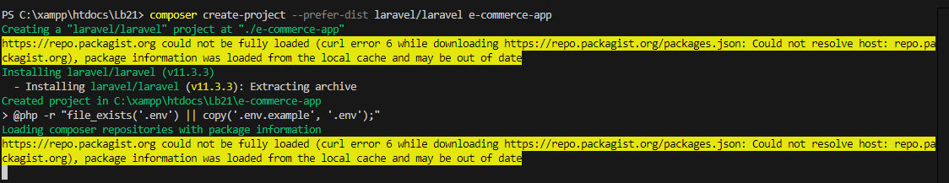
composer create-project --prefer-dist laravel/laravel e-commerce-app

- Create model & migration

php artisan make:model Product -m

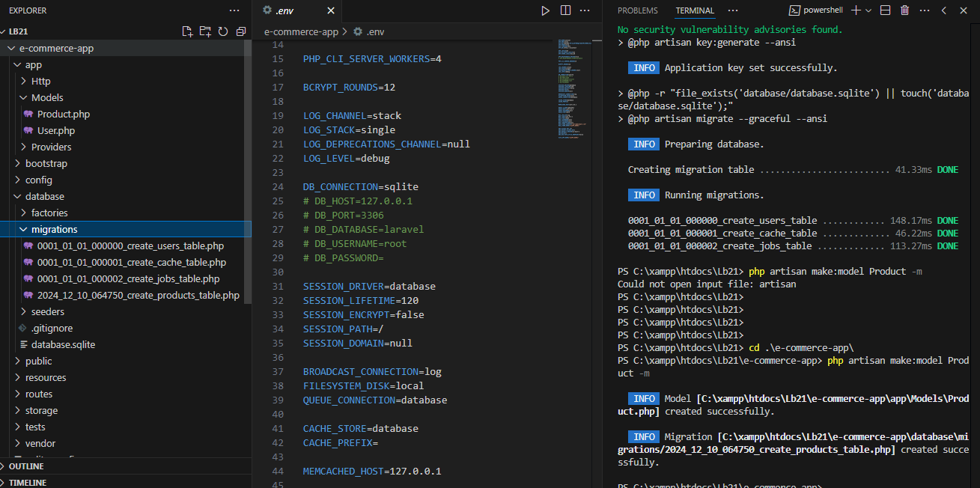

- Create controller

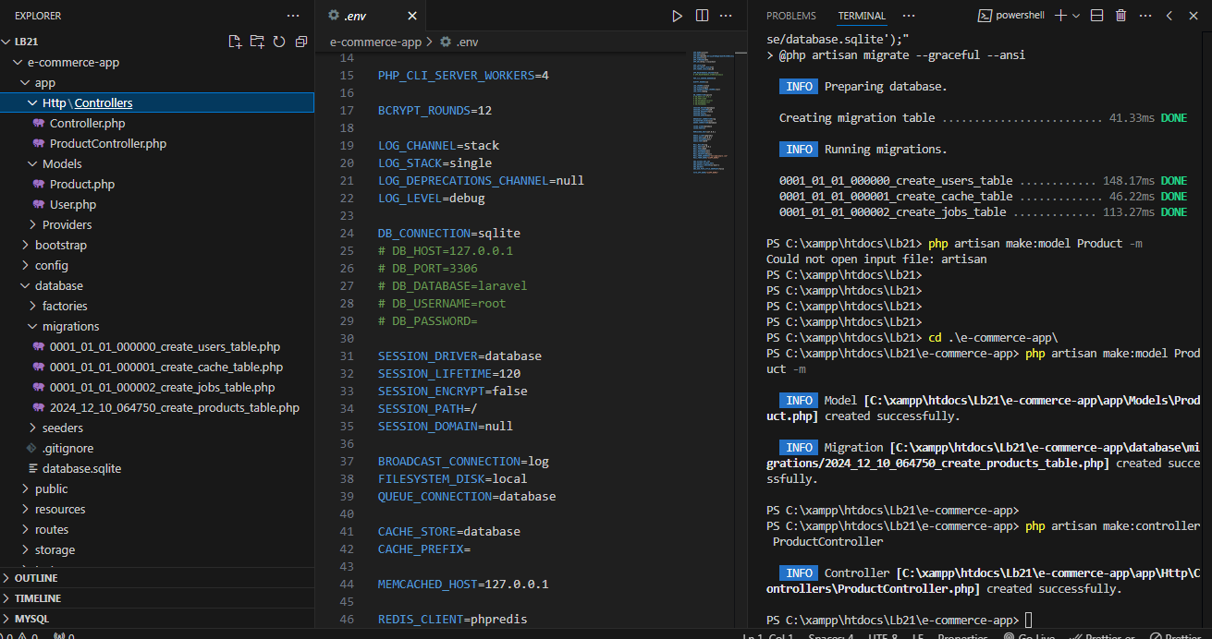
php artisan make:controller ProductController

- Create request

php artisan make:request CreateProductRequest

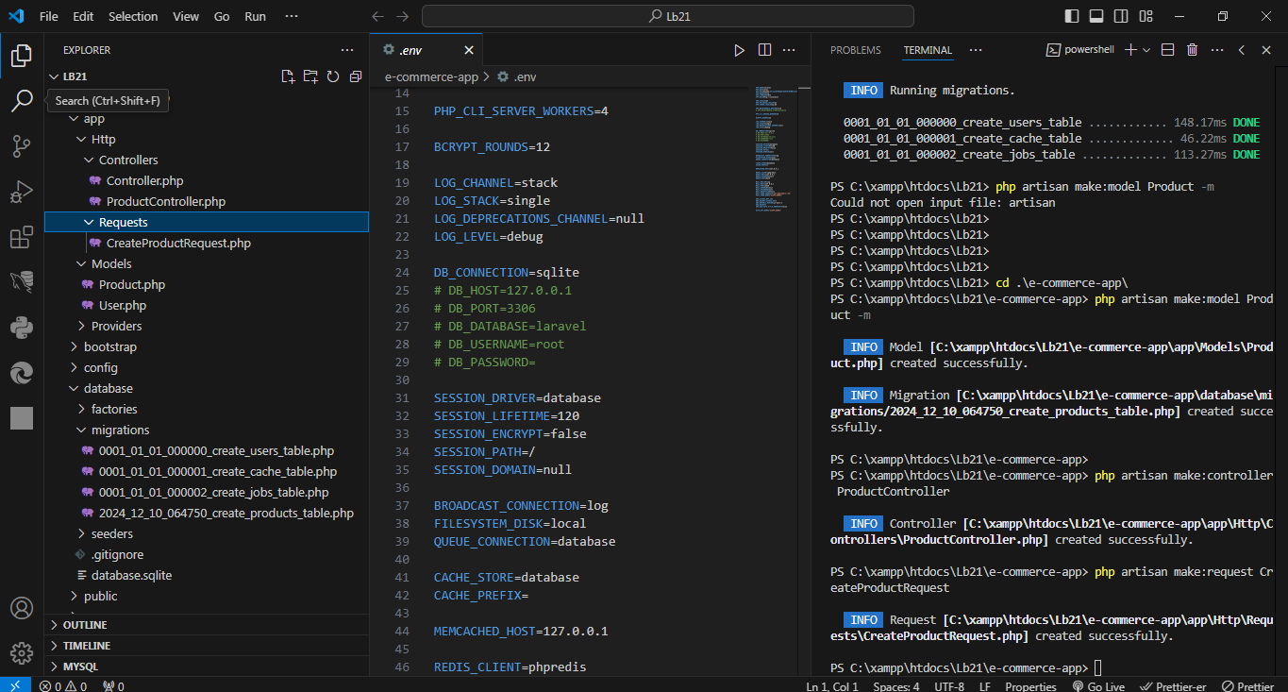

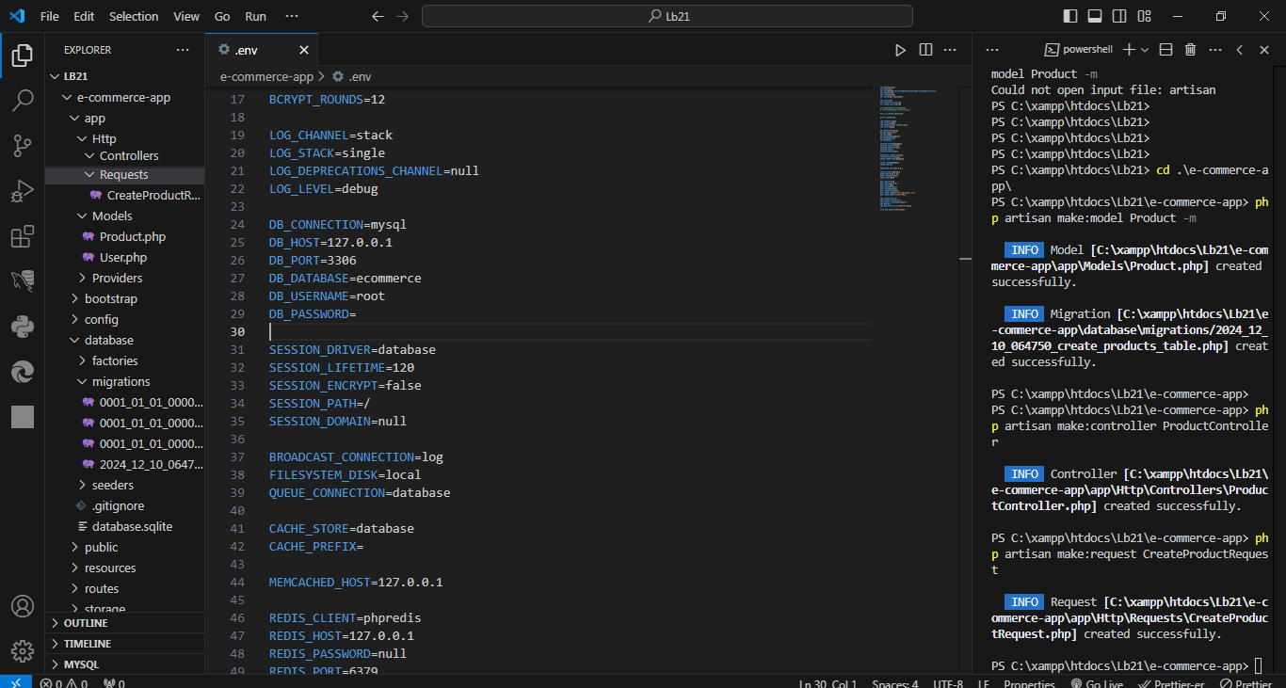
- Update .env file

6. Complete Product model
class Product extends Model{
use HasFactory;
protected $fillable = [
'name',
'description',
'image',
'price',
];
}
Product.php
<?php

namespace App\Models;

use Illuminate\Database\Eloquent\Model;

class Product extends Model
{
use HasFactory;

protected $fillable = [
'name',
'description',
'image',
'price',
];
}

7.Complete migrations
public function up(): void{
Schema::create('products', function (Blueprint $table) {
$table->id();
$table->string('name');
$table->text('description');
$table->string('image');
$table->decimal('price', 10, 2);
$table->timestamps();
});
}

2024_12_10_064750_create_products_table.php
<?php

use Illuminate\Database\Migrations\Migration;
use Illuminate\Database\Schema\Blueprint;
use Illuminate\Support\Facades\Schema;

return new class extends Migration
{
/**
* Run the migrations.
*/
public function up(): void{
Schema::create('products', function (Blueprint $table) {
$table->id();
$table->string('name');
$table->text('description');
$table->string('image');
$table->decimal('price', 10, 2);
$table->timestamps();
});
}

/**
* Reverse the migrations.
*/
public function down(): void
{
Schema::dropIfExists('products');
}
};

8. Run the migrations

php artisan migrate

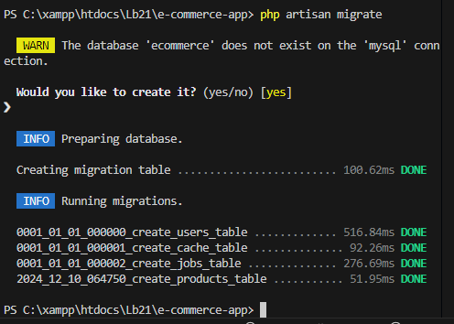

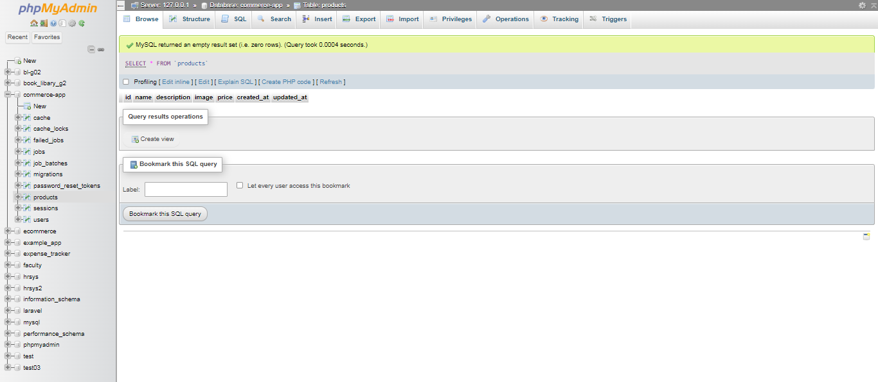

9. Implement CRUD operation
public function all(){
return Product::all();
}
public function store(CreateProductRequest $request){
$imagePath = $request->file('image')->store('products','public');
$product = Product::create(['name' => $request->validated('name'),'description' => $request->validated('description'),'price' => $request->validated('price'),'image' => $imagePath,]);
return $product;
}
public function get($id){
return Product::findOrFail($id);
}
public function update(Request $request, $id){
$product = Product::findOrFail($id);
return $product->update($request->all());
}
public function delete($id){
$product = Product::findOrFail($id);
return $product->delete();
}

<?php

use App\Models\Product;
use App\Http\Requests\CreateProductRequest;

class ProductController extends Controller
{
// Get all products
public function all()
{
return Product::all();
}

// Store a new product
public function store(CreateProductRequest $request)
{
$imagePath = $request->file('image')->store('products', 'public');

$product = Product::create([
'name' => $request->validated('name'),
'description' => $request->validated('description'),
'price' => $request->validated('price'),
'image' => $imagePath,
]);

return $product;
}

// Get a single product by ID
public function get($id)
{
return Product::findOrFail($id);
}

// Update an existing product
public function update(Request $request, $id)
{
$product = Product::findOrFail($id);
$product->update($request->all());

return $product;
}

// Delete a product
public function delete($id)
{
$product = Product::findOrFail($id);
$product->delete();

return response()->noContent();
}
}

10. Complete request

<?php

namespace App\Http\Requests;

use Illuminate\Foundation\Http\FormRequest;

class CreateProductRequest extends FormRequest
{
/**
* Determine if the user is authorized to make this request.
*/
public function authorize(): bool
{
return false;
}

/**
* Get the validation rules that apply to the request.
*
* @return array<string, \Illuminate\Contracts\Validation\ValidationRule|array<mixed>|string>
*/
public function rules()
{
return [
'name' => 'required|string|max:255',
'description' => 'required|string',
'price' => 'required|numeric|min:0',
'image' => 'required|image|mimes:jpg,jpeg,png,gif|max:2048',
];
}

}

11. Implement routes

<?php

use Illuminate\Support\Facades\Route;
use App\Http\Controllers\ProductController;

Route::get('/', function () {
return view('welcome');
});

Route::get('products', [ProductController::class, 'all']);
Route::post('products', [ProductController::class, 'store']);
Route::get('products/{id}', [ProductController::class, 'get']);
Route::put('products/{id}', [ProductController::class, 'update']);
Route::delete('products/{id}', [ProductController::class, 'delete']);

12. Implement new route for get token
Route::get('/token', function () {
return csrf_token();
});
<?php

use Illuminate\Support\Facades\Route;
use App\Http\Controllers\ProductController;

Route::get('/token', function () {
return csrf_token();
});

Route::get('products', [ProductController::class, 'all']);
Route::post('products', [ProductController::class, 'store']);
Route::get('products/{id}', [ProductController::class, 'get']);
Route::put('products/{id}', [ProductController::class, 'update']);
Route::delete('products/{id}', [ProductController::class, 'delete']);

13. Open postman
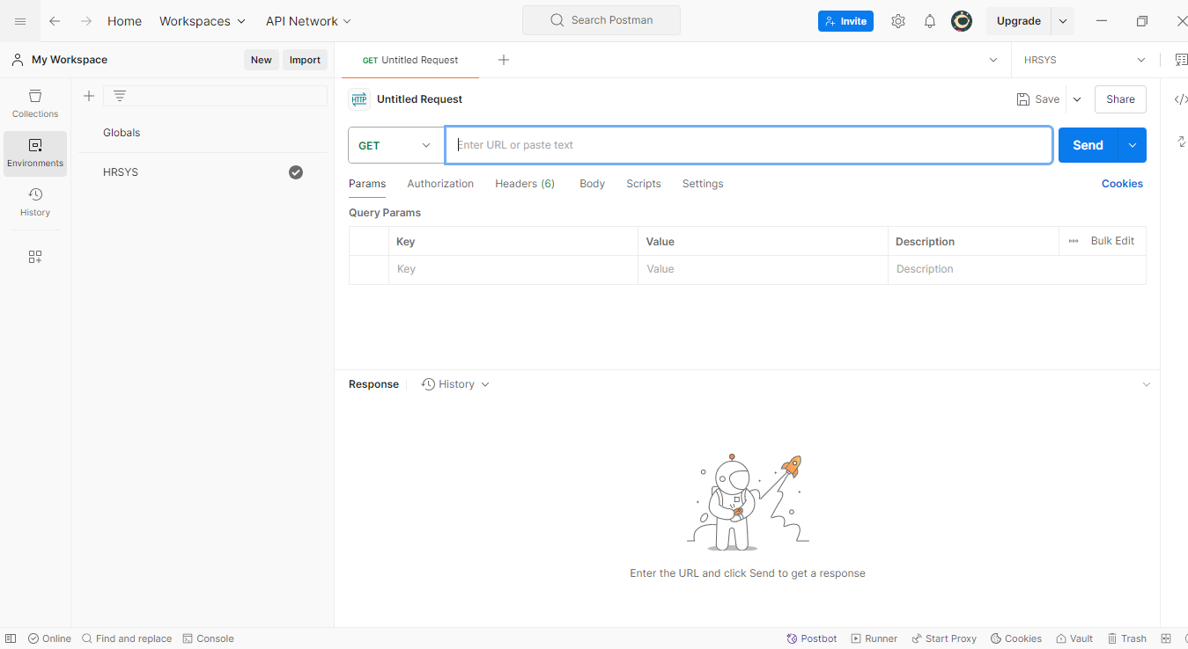

14. Run the token route

http://localhost:8000/token

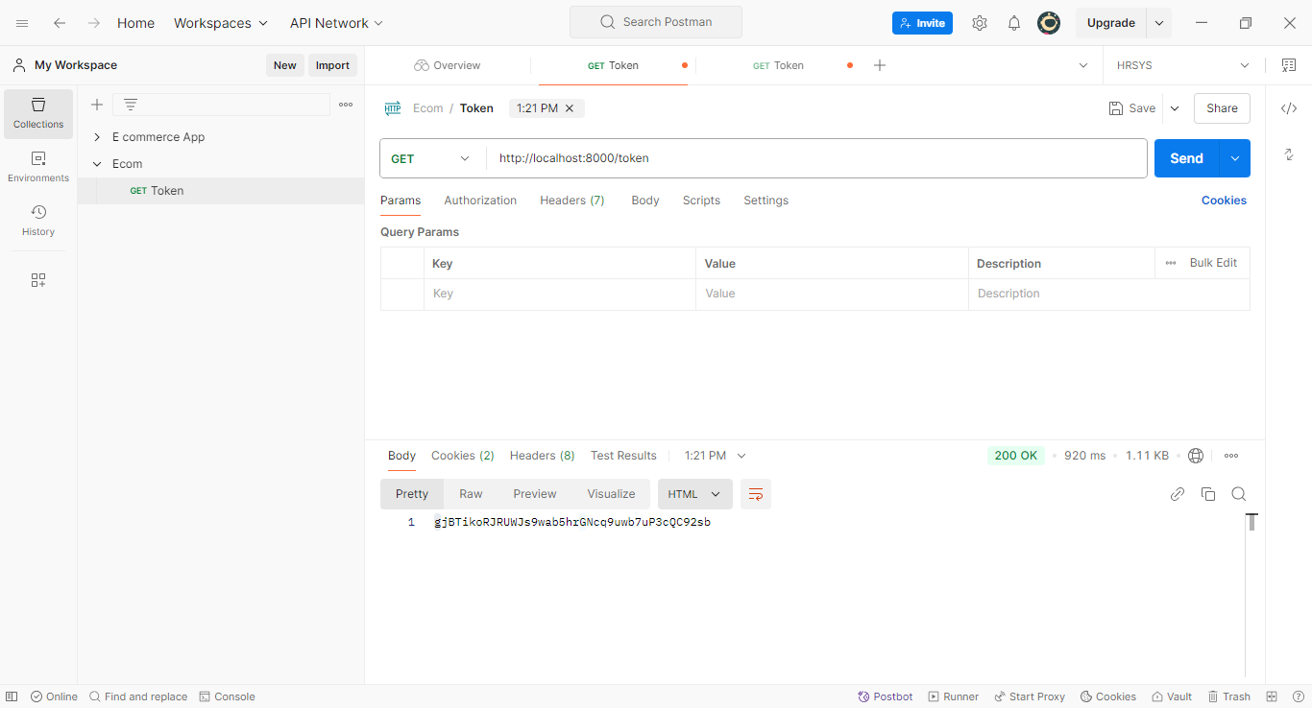

15. Save token in header

http://localhost:8000/products/store?XSRF-TOKEN=gjBTikoRJRUWJs9wab5hrGNcq9uwb7uP3cQC92sb
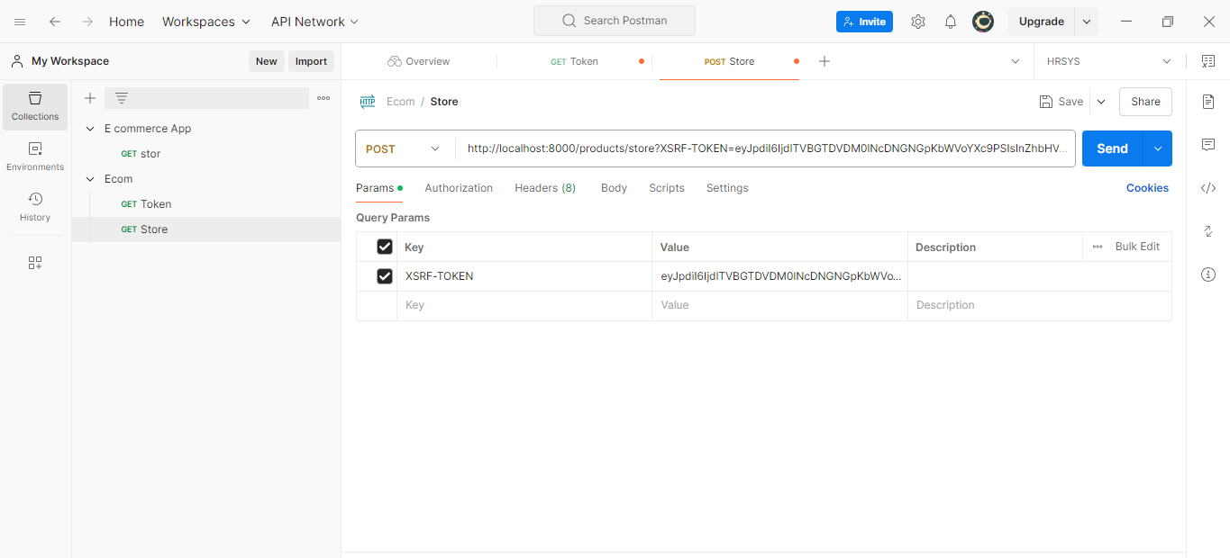

16. Run the requests
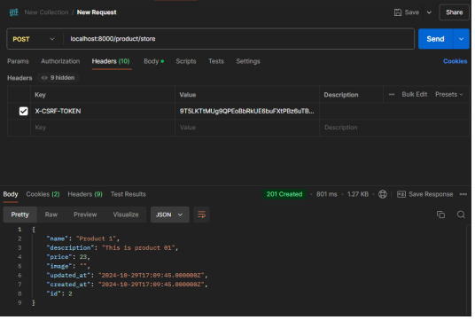
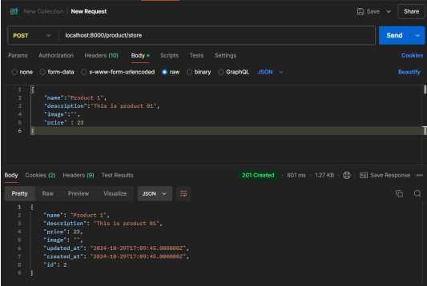

Discussion:
- In this lab practical session, I worked on implementing the backend of an e-commerce application using Laravel. The first task was to create a new Laravel project, which provided the foundation for the application. I then created the necessary model, migration, controller, and request to manage products in the e-commerce system. This involved defining the product's attributes in the model, setting up the database schema through migrations, and handling validation using the request class. I implemented CRUD operations to allow for creating, reading, updating, and deleting products. Finally, I tested the endpoints using Postman to ensure the functionality was working correctly. This practical session helped me gain hands-on experience with Laravel's powerful features and how to build a simple backend API.

